SF3: Machine Learning

Final Report

Oscar Saharoy

**Abstract.** Machine learning is a rapidly advancing field with applications across the world. I investigate the classic cartpole system and apply fundamental machine learning techniques to model and control the system.

**Task 1.1 -** Simulation of Rollout

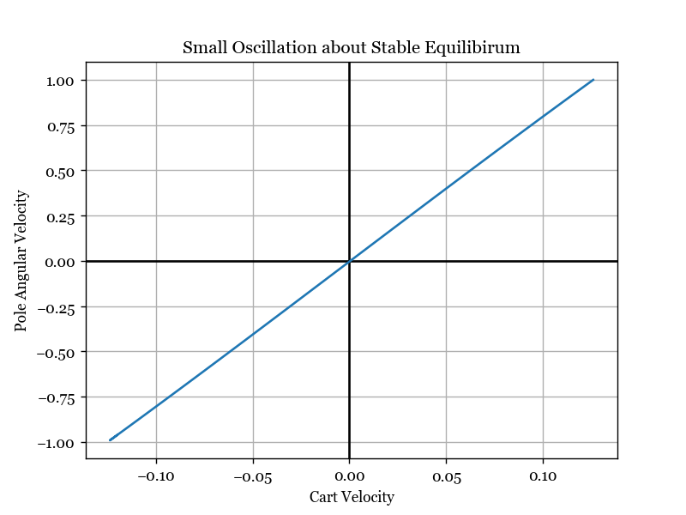I established a few different initial conditions for the cartpole system and then plotted graphs to represent the resulting motions. I recorded the values of the state vector as the system evolved and then plotted some of the elements of the vector against each other at each timestep to form a curve.

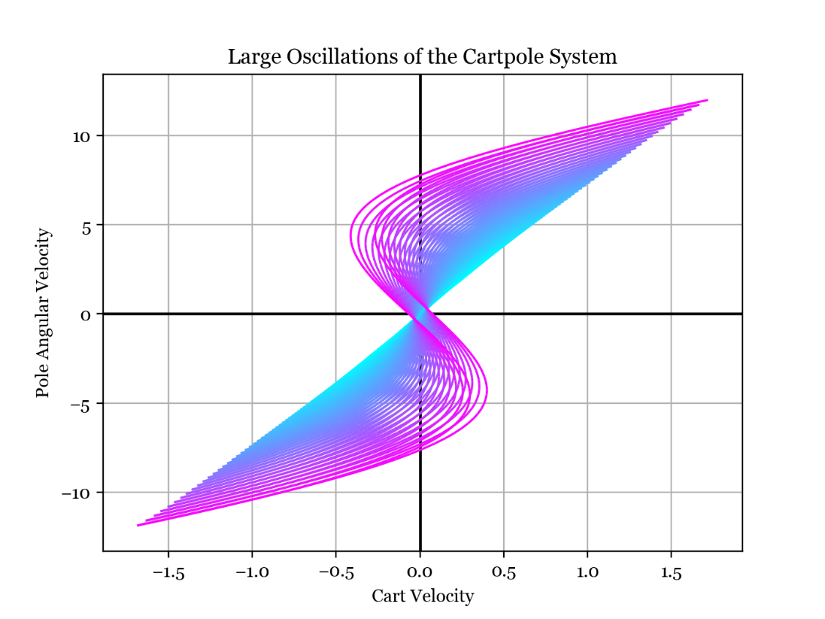**Small Oscillation about Stable Equilibrium.** The plot on the left shows pole angular velocity plotted against cart velocity as time progresses through small oscillations - the system traverses up and down the blue line as the pole swings. The linear trend reflects the small angle assumption - the restoring force from the pendulum is a linear function of the deflection. From linear vibration theory we know the cart and pole vibrate at the same frequency so they "move together" and so their velocities are linearly correlated.

**Large Oscillations**. The plot to the right shows large amplitude oscillations, with the line turning from magenta to cyan as time progresses. The small angle approximation no longer holds, with the curve of the lines showing the tendency of the cart to change direction during the pole's swing. The plot shows how the amplitude and curvature of the line decreases as energy is dissipated and we return to the small oscillation regime.

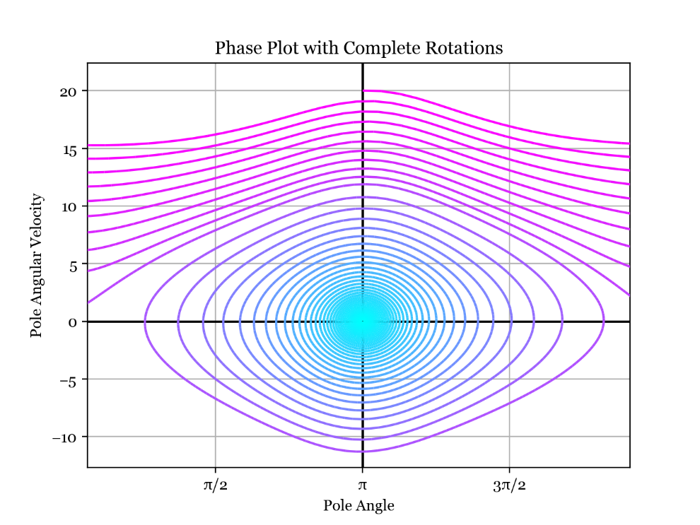**Full Revolutions.** This is the phase portrait of the pole angle and angular velocity, again starting from magenta and going to cyan. The upper region is where full rotations of the pole occur; then when enough energy is dissipated the system falls into the lower spiral towards the stable equilibrium at a pole angle of pi.

**Task 1.2 -** Changes in State

The change in state vector over the next time step $Y=X\left(T\right)-X(0)$  is related to the current state vector $X\left(0\right)=[x, \dot{x},θ,\dot{θ}]$  by some complex function which I want to model. I made some plots showing how the change in state vector depends on the current state vector, noting that the change in state vector is not a function of the cart position due to the translational symmetry/invariance of the system.

It is more helpful to investigate the change in state as a function of the initial state rather than the subsequent state as a function of the current state. This is because the subsequent state will be quite similar (almost linearly related) to the initial state, assuming a small timestep. We can capture more meaning in our model by investigating the change in state, which subtracts off the information we already know (the initial state).

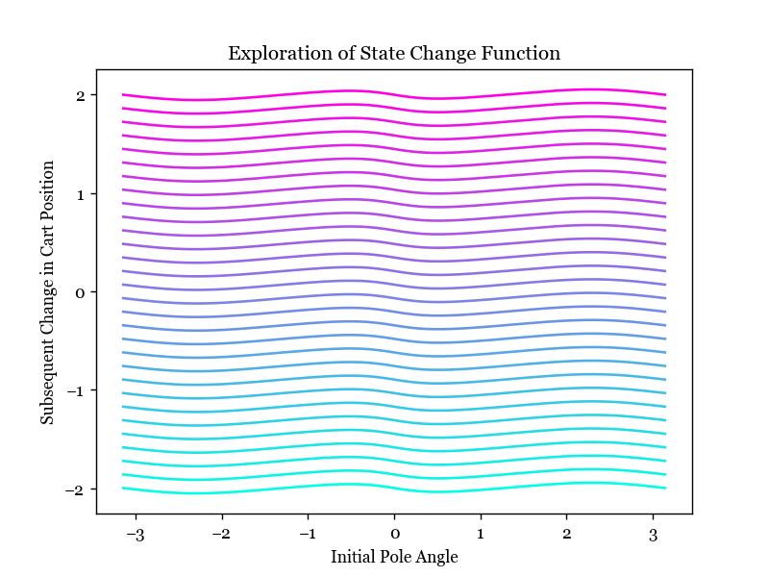**Varying Initial Cart Velocity and Pole Angle.** In the plot to the right, I am varying initial pole angle along the lines in the x direction, and varying initial cart velocity between lines, from -10 in cyan to +10 in magenta. The y axis is the change in cart position. We can see that the lines are equally spaced, so the change in cart position seems to be a linear function of cart velocity which makes sense.

However, the change in cart position is a slightly nonlinear function of the pole angle since there is a wobble in the lines. Plotting the changes in other state variables in this way yields coincident lines which are better represented in the contour plot below.

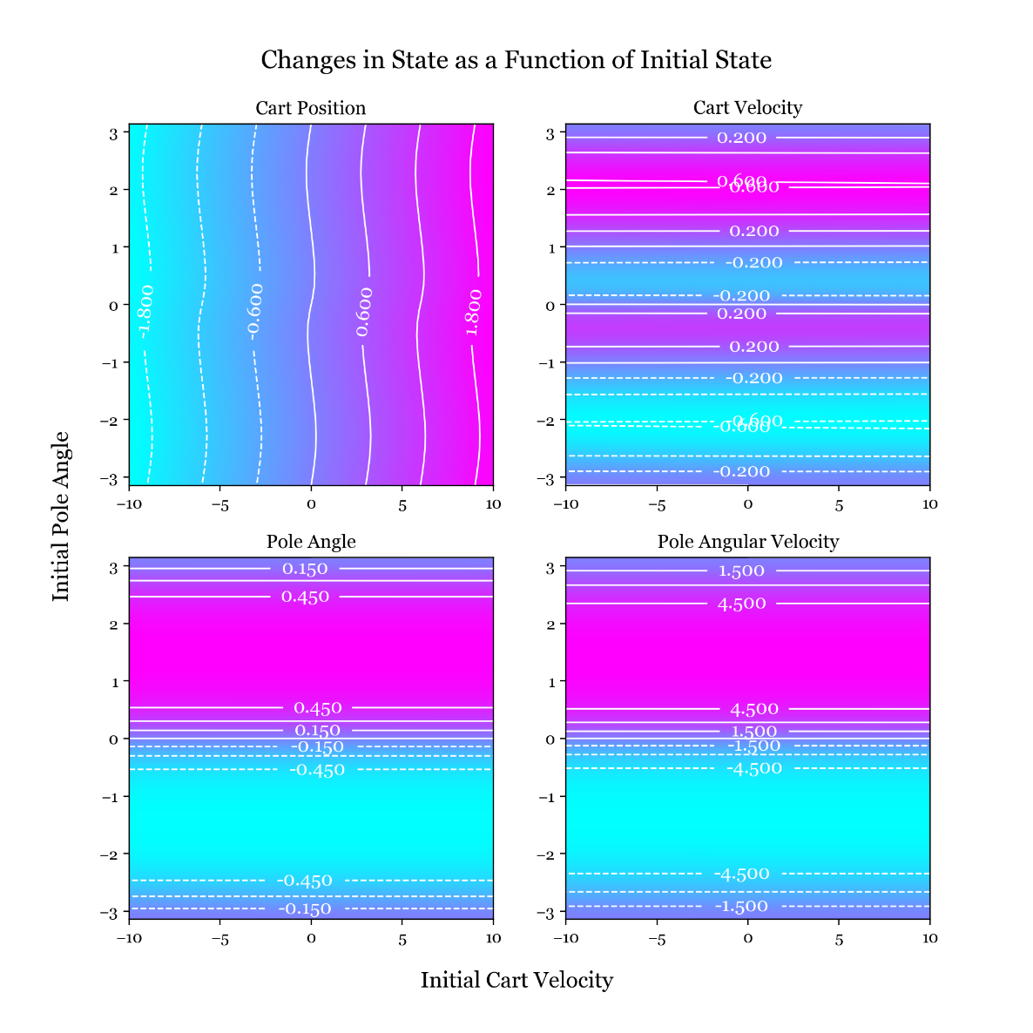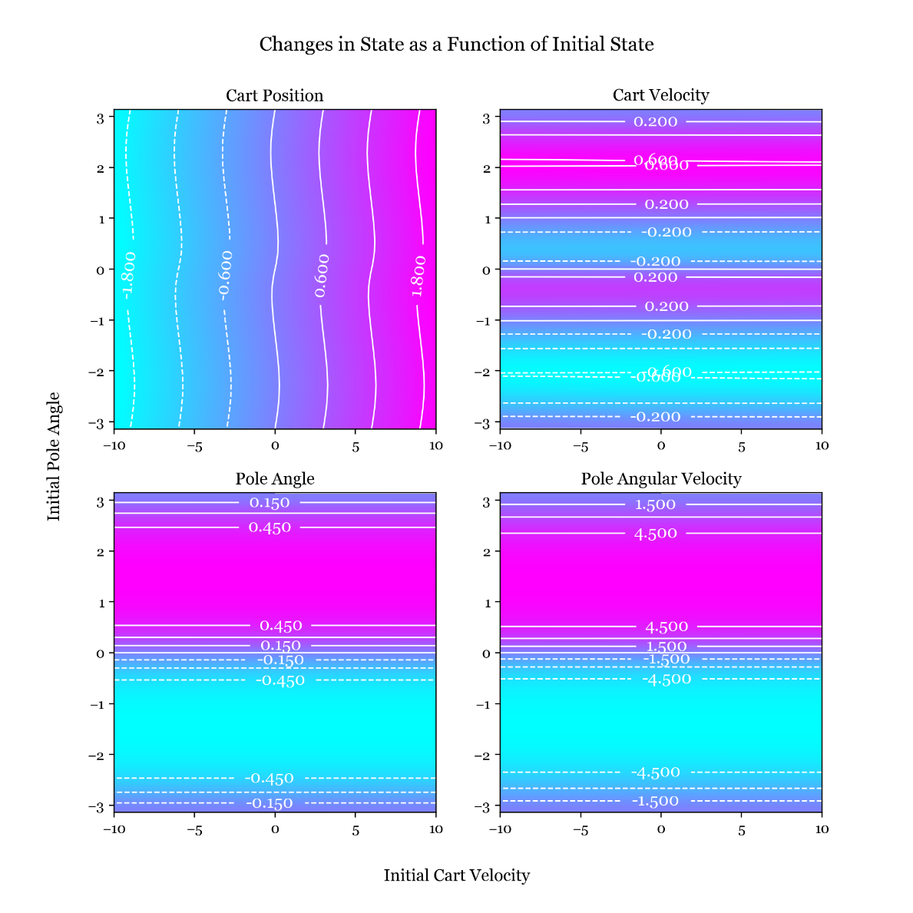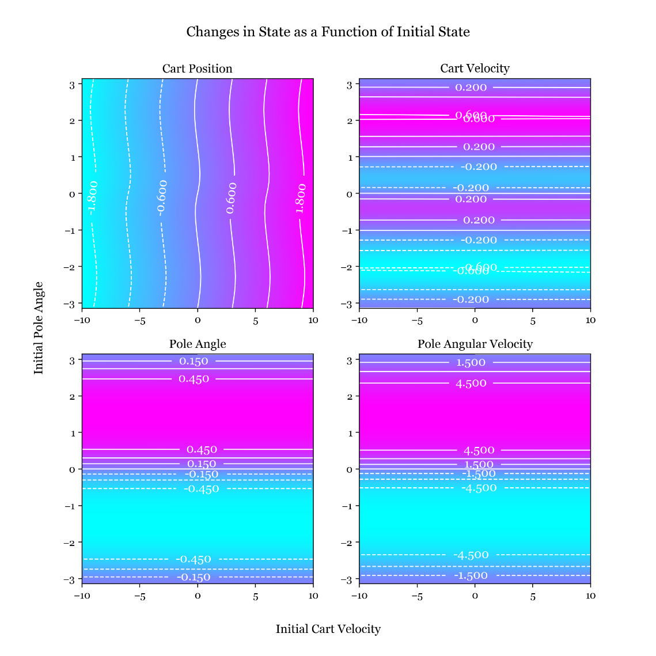In this plot, the initial cart velocity varies in the x direction and the initial pole angle in the y direction. The subsequent changes in the state vector are shown as contour plots. The changes in cart velocity, pole angle and pole angular velocity are not functions of the initial cart velocity. This must be the case because any initial cart velocity can be achieved by assuming a different inertial reference frame, leaving the rest of the dynamics unchanged.

I also tried different initial conditions for all contours plots and found that the structure was similar but with slightly different values.

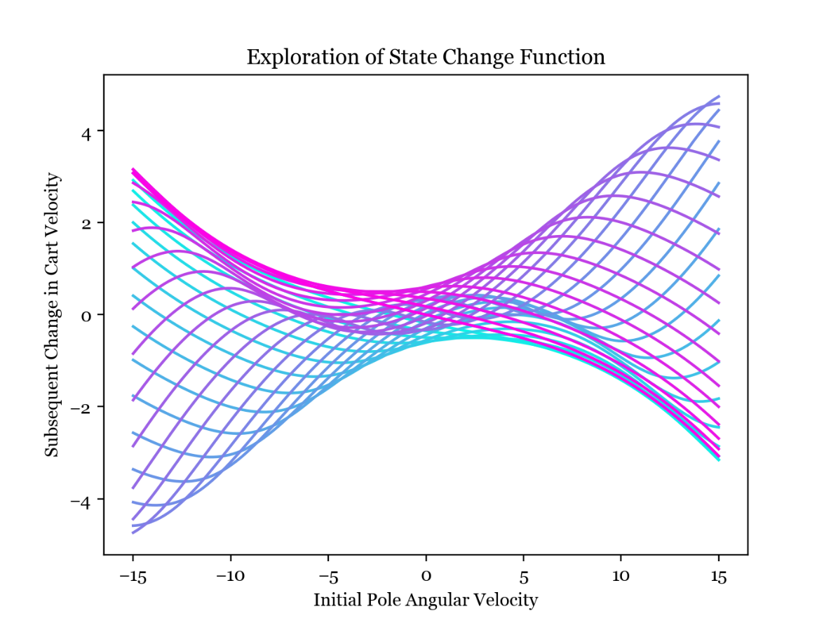The same reasoning leads to the contour plots for varying cart velocity and pole angular velocity consisting of straight lines so I will move to the more interesting combination of varying pole angle and angular velocity.

**Varying Initial Pole Angle and Angular Velocity.** The plot to the right shows how the change in cart velocity at the next time step is a highly nonlinear function of the two variables that we are changing in the plot - the initial pole angle and angular velocity. The more cyan curves are an initial angle around −𝜋 and the more magenta curves are an initial angle around 𝜋.

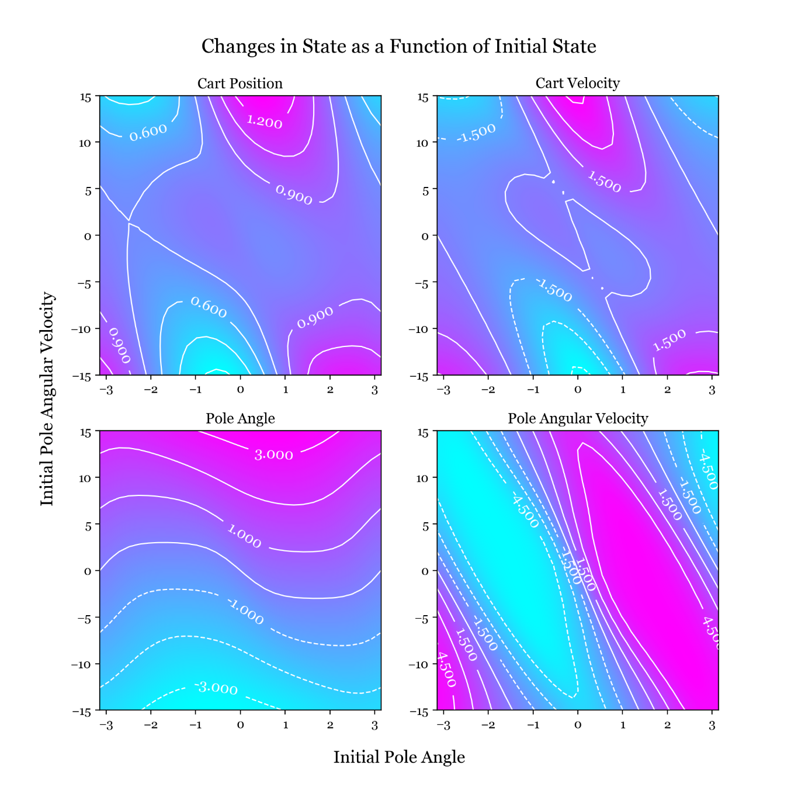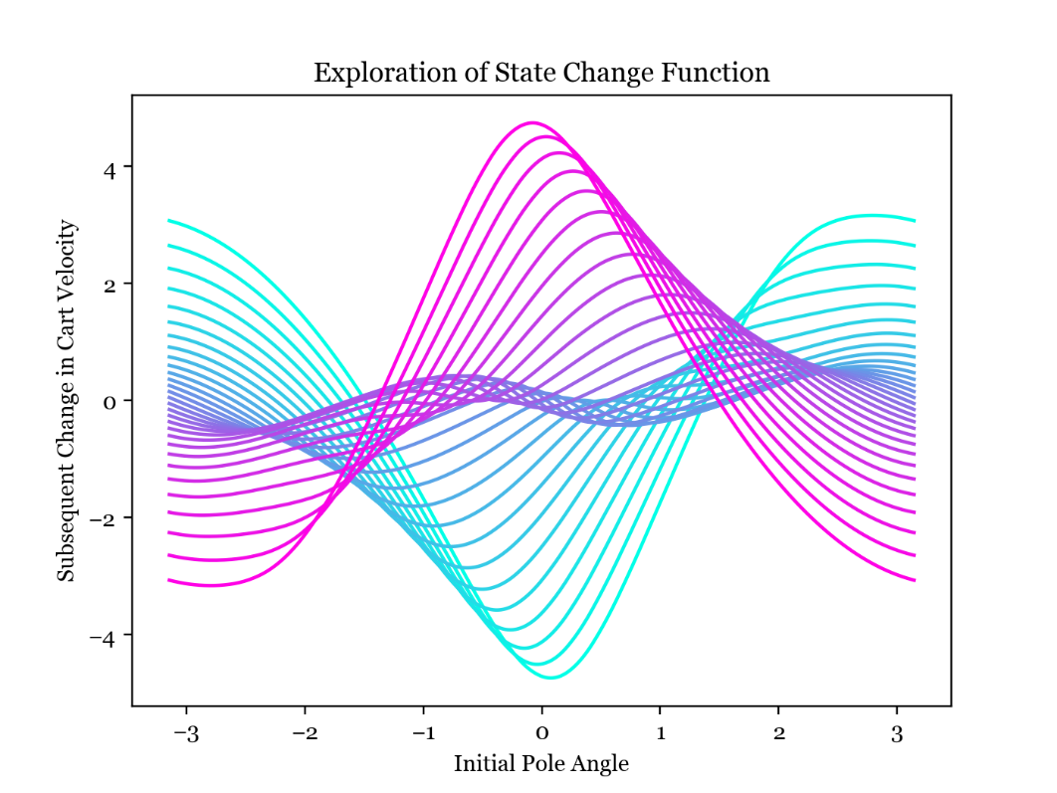This is the same as the plot above but this time plotting change in cart velocity as a function of initial pole angle, varying the initial angular velocity from -15 in cyan to +15 in magenta. It looks like a linear estimator of 𝑌 from 𝑋 will perform poorly, but looking at the central, dense part of the graph above (which represents a small initial angular velocity) we can see the curvature of the lines are much smaller. Keeping in mind the truncated Taylor series approximation to a function for small deviations, there is some scope to use linear estimation especially for small deviations about an equilibrium.

In these contour plots I vary initial pole angle in the x direction and initial pole angular velocity in the y direction and show the changes in the state variables in the contour plots. It is quite hard to find linearity within. However, it makes sense that the change in pole angle appears to be a mostly linear function of the pole angular velocity, with some dependence on the pole angle due to gravity acting on the pole.

**Task 1.3 –** Linear Model

**Finding the Least-Squares Fit.** I assume that the change in state is a linear function of the current state:

$$Y=f(X)=XC$$

where $C$ is a 4x4 matrix. First, I generated 500 input/output pairs by randomly generating initial states and then performing 1 step (one call to perform_action) to generate subsequent states, and then used the Moore-Penrose inverse of $X$ to find the least-squares linear fit.

$$Y=XC$$

$$X^{+}Y=X^{+}XC=C$$

I then investigated the linear predications and compared them to the analytic target data.

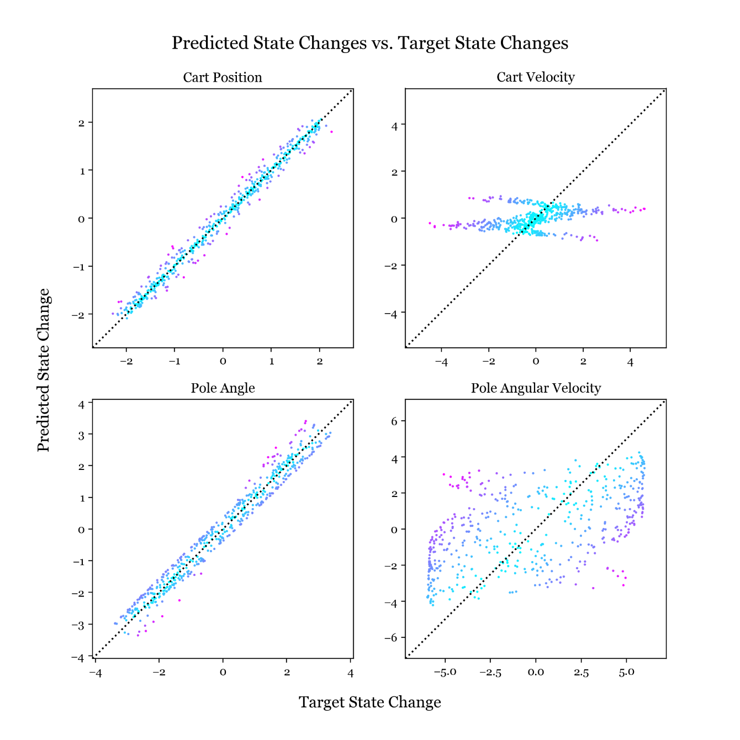**Predicted State Change vs. Target State Change.** Here I have plotted one point per training data element on a graph for each element in the state change vector. For each point, the x coordinate is the target change in state as returned from perform_action and the y coordinate is the predicted change as returned by the linear estimator. So for perfect predictions these would be equal, and the points would all lie on the line $y=x$ shown in dotted black.

The changes in cart position and pole angle are well predicted by the linear estimator, with the points lying close to the ideal line. The change in cart velocity as least has the central mass of points lying near the ideal line, but with many outliers at the edges, while the change in pole angular velocity is very poorly explained by the linear model with the points avoiding the ideal line.

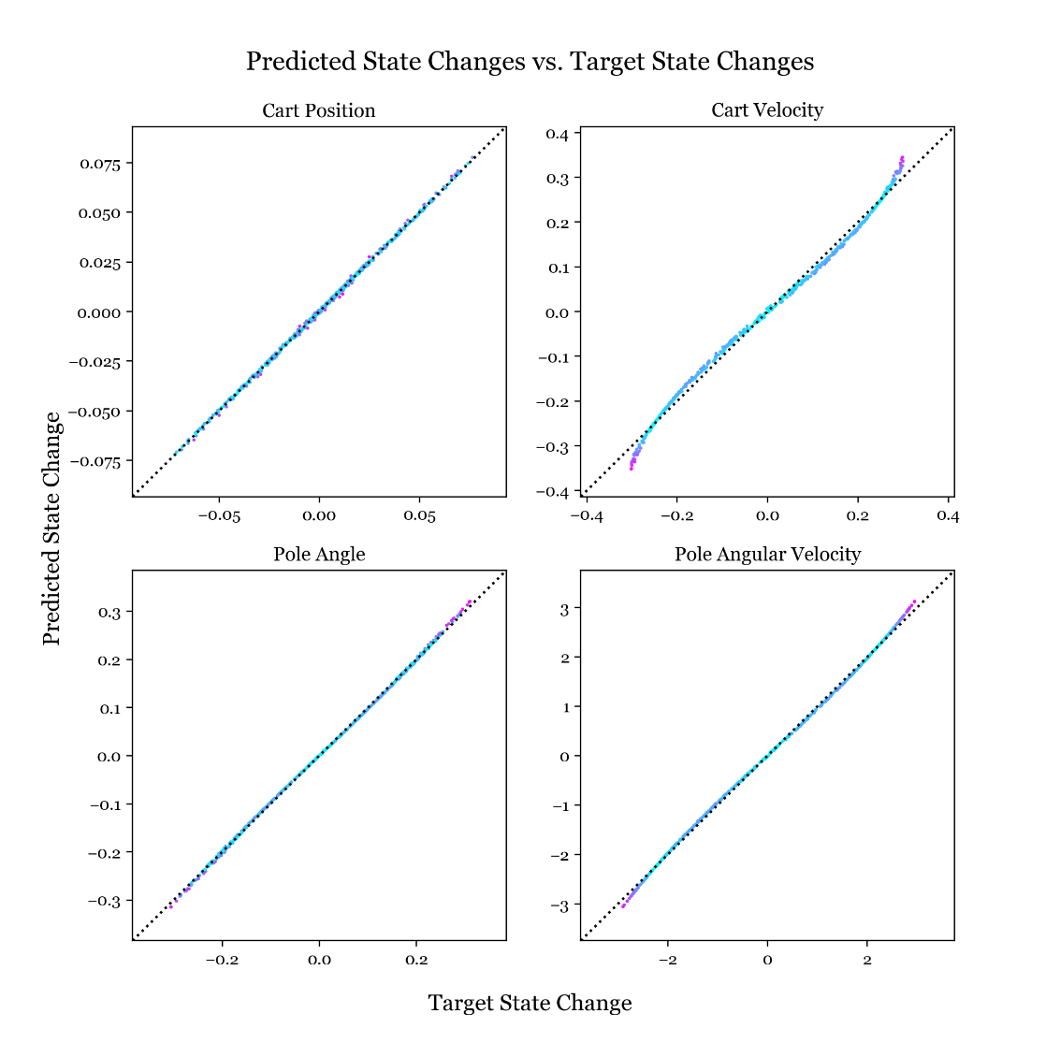**Linear Model for Small Deflections Only.** I repeated the above procedure but limited the training data to small deflections from equilibrium (initial states between -0.25 and 0.25). Thinking back to the Taylor series approximation for a function I expected this scheme to yield better predictions near the equilibrium.

The linear model works nicely for small deflections as shown opposite, with all the points near to the ideal lines. Perhaps we could build a good model by using many linear models centred around different points, which provides motivation for moving to a nonlinear model.

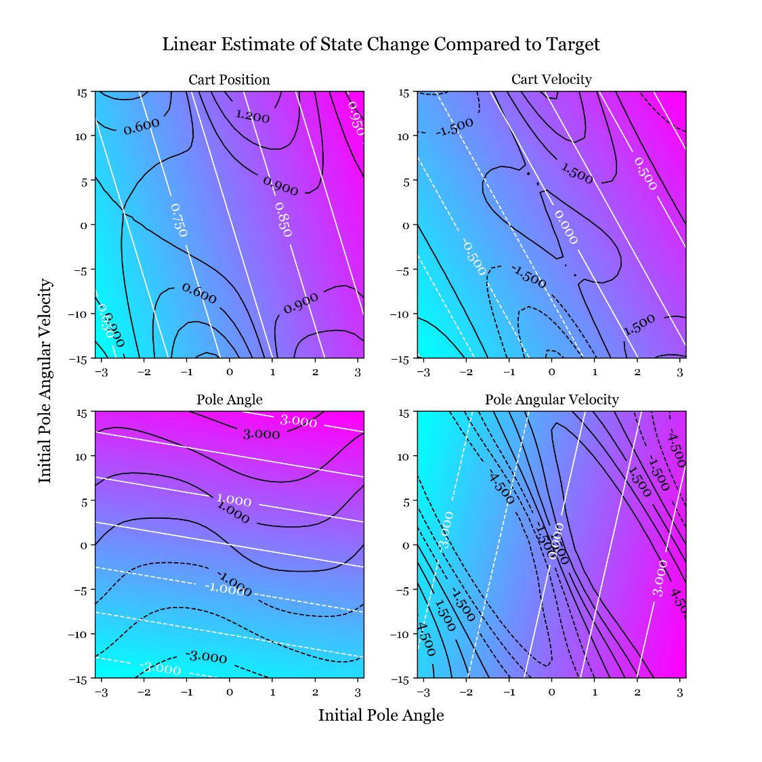**Prediction Contour Plots vs. Target Contour Plots.** I generated 4 contour plots, shown bottom right, for the predicted state change of each the state vector elements as predicted by the linear model. I am varying the initial pole angle and angular velocity again, so I am aiming for these contour plots to be identical to the final 4 I plotted in task 1.2. Note that I am back to using the linear estimate for the entire range of data.

The contours from the linear estimator are in white and the target contours are in black. It seems the nonlinearities in the data have been discarded and the linear estimator has picked up on only the lowest-frequency linear trends. I would expect this model to miss the nuance in the motion of the cartpole - especially the nonlinear rotational dynamics of the pole.

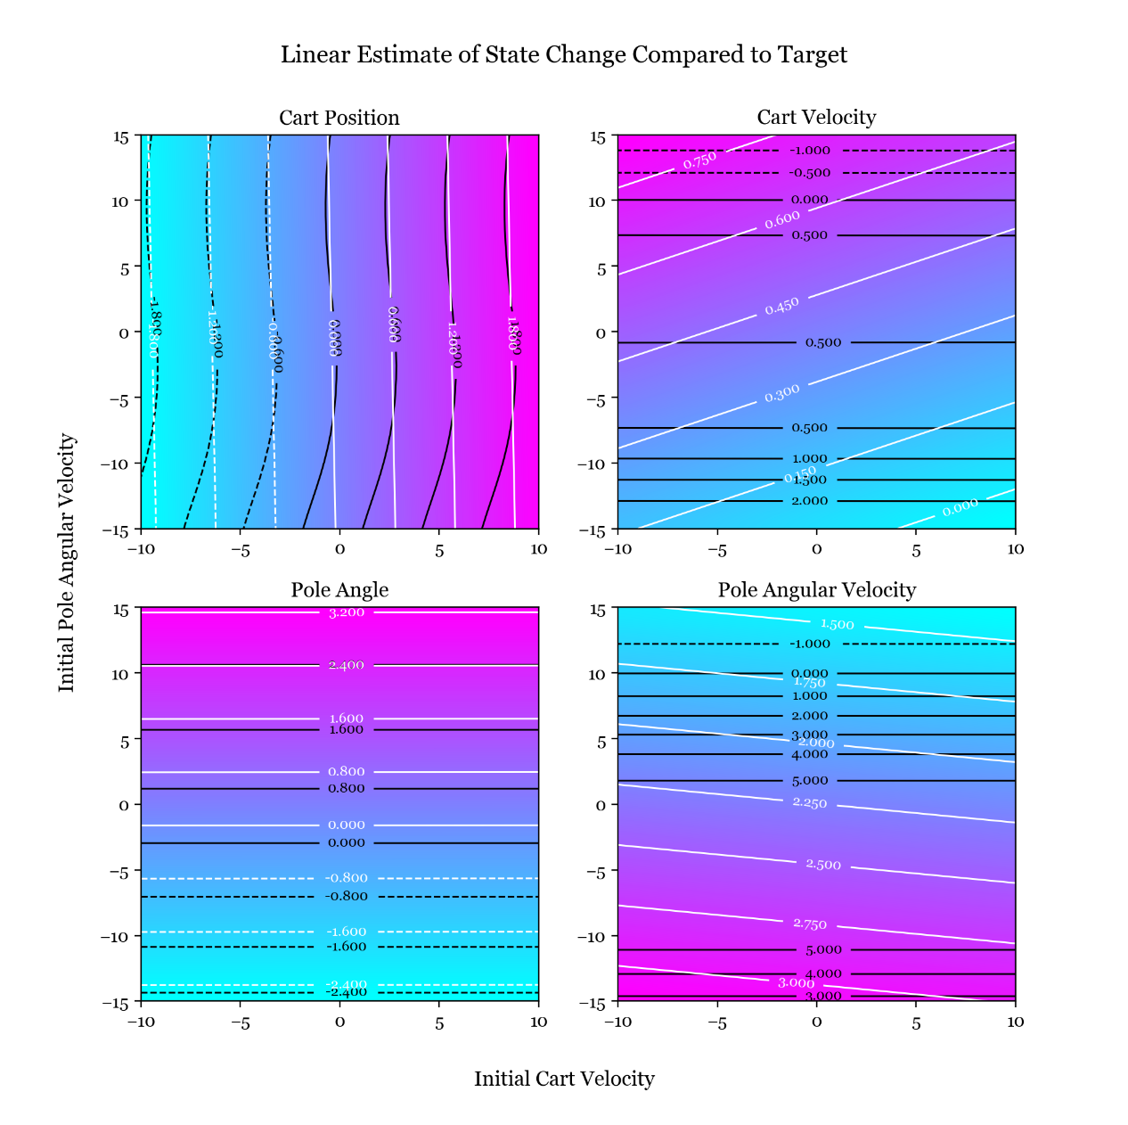However, the linear estimator makes some good predictions when contours are plotted over varying initial cart velocity and pole angular velocity as shown left. This is the pair of variables I didn't plot contours for in task 1.2, but here we can see how the two trends on the left are closer to linear and the white and black contour lines are in close agreement. This mirrors the results from the scatter plots where the predictions for change in cart position and pole angle were most accurate.

**Prediction Accuracy.** The elements that are well predicted by the linear model are the change in cart location and pole angle. The change in cart location will be quite similar to the velocity of the cart times the timestep (neglecting acceleration during the timestep), so it is expected that we could predict this as a linear function of the velocity. The change in pole angle is similarly related to the angular velocity.

**Task 1.4 -** Prediction of System Evolution

Now the linear model can predict the system evolution by incrementing the current state by the prediction for the state change repeatedly. This can be used as an alternative to the analytic system dynamics, so I have made similar plots to task 1.1 but now using the linear model rather than the actual dynamics.

**Remapping.** It is vital to remap the pole angle to the range −𝜋 to 𝜋 during this process. If this is not done, the angle grows beyond anything seen in the training data and the result is an abnormally large input of energy to the system which causes divergence. If we don’t remap, the state after $k$ steps $X_{n+k}=X{(C+I)}^{k}$ and diverges since $C+I$ will likely have eigenvalues greater than 1.

**Small Oscillations.** The plot below and right is initialised the same as the small oscillations case from the first plot in this report, and shows the time evolution of the pole angular velocity plotted 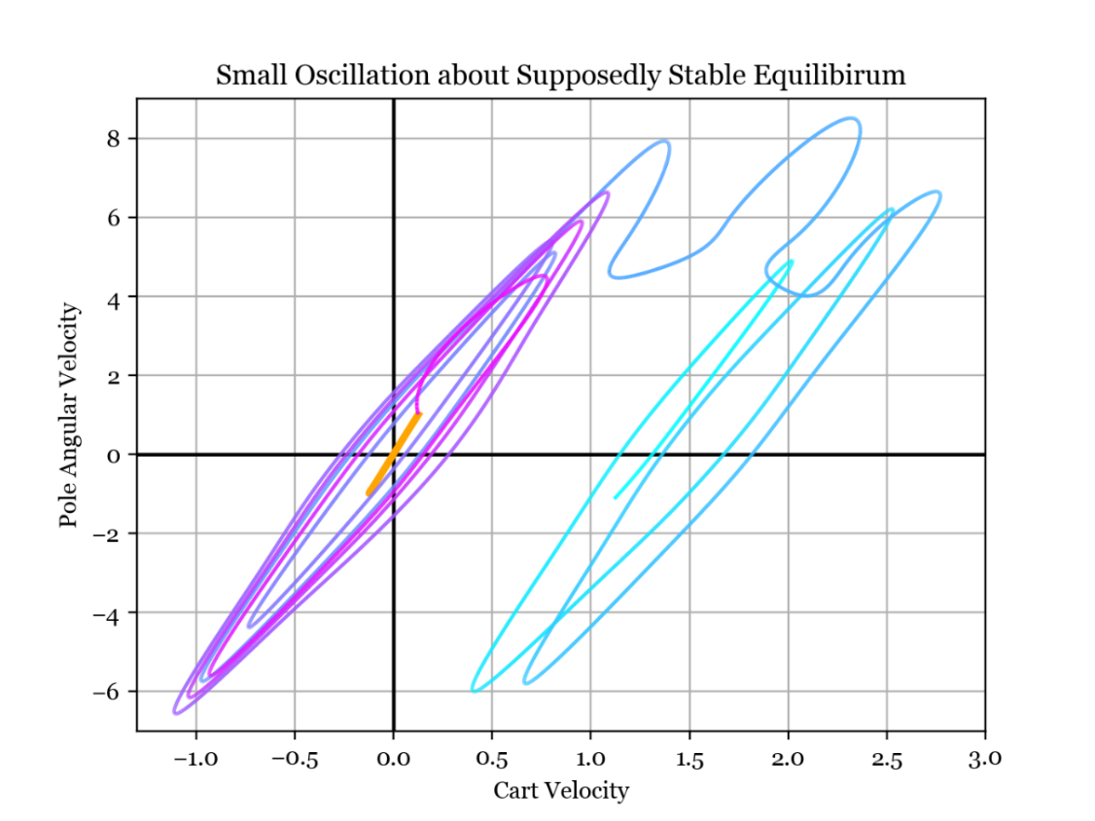against cart velocity. The target behaviour is shown in orange, which is the data from the small oscillation plot using the analytic dynamics. The linear estimation time evolution is the curve that starts in magenta at initialisation and turns more cyan as time goes on.

**-** Actual Dynamics

**-** Predicted Dynamics

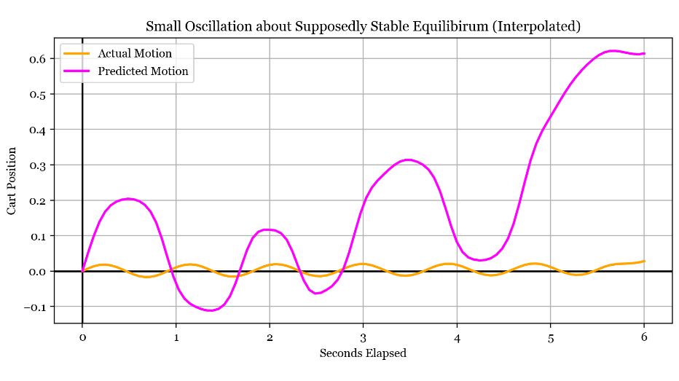The linear model successfully brings the system into an oscillating state, shown by the loops about the origin, although these oscillations are of much larger amplitude than they should be (the loops are larger than the orange line). After a few oscillations, the system spontaneously shifts into a regime where it is still oscillating but also moving to the right, shown by the loops shifted to the right. The random increase in kinetic energy indicates that conservation of energy is a nonlinear detail in the data that the linear model struggles to capture. It's important to note that this is a particularly lucky result based on favourable random generation of training data - most plots I made with other training data explosively diverged from the oscillating regime in fewer time steps.

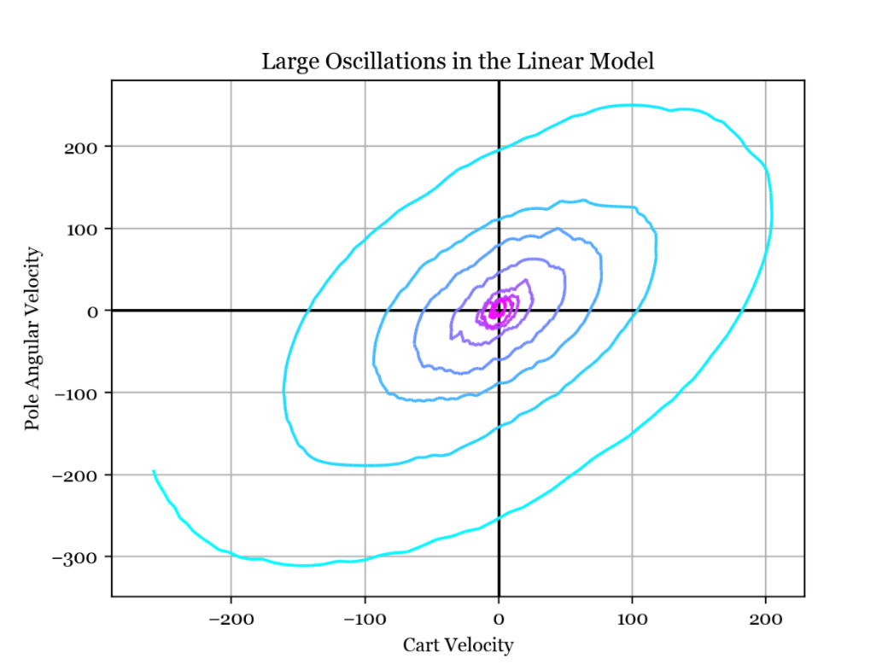The left plot shows the predicted and actual cart position over time. The linear model has managed to capture the oscillatory motion, but the amplitude and frequency are incorrect and the position diverges as time progresses.

**Large Oscillations and Complete Revolutions.** This plot is initialised with a larger pole angular velocity so that the oscillations start larger and grow to full revolutions. As time progresses the line goes from magenta to cyan, and both the pole angular velocity and cart velocity immediately diverge, reaching large values. However, the spiral structure conveys some understanding that a larger cart velocity implies a smaller pole angular velocity.

**Task 2.1 –** Nonlinear Modelling

To improve the linear model, I will try to express the state change from a given state $f(X)$ in the form:

$$f\left(X\right)=\sum_{i}{α_{i}K\left(X,X_{i}\right)}$$

This is a nonlinear model where the state change is found as a weighted sum of radial basis functions. Basis function $i$ iscentred at $X_{i}$ and hasweights $α_{i}$, and the basis function $K$ is a Gaussian. The weights are found by regularised least-squares regression, so the regularisation constant $l$ and the length scale of the Gaussians are hyperparameters to be tuned.

**Generating Training Data.** Now that I wish to improve the state change model with nonlinear basis functions, the first task is to generate training data. For task 1.3 I used uniformly distributed random datapoints, but this time I am using a Sobol sequence to generate more evenly spaced data.

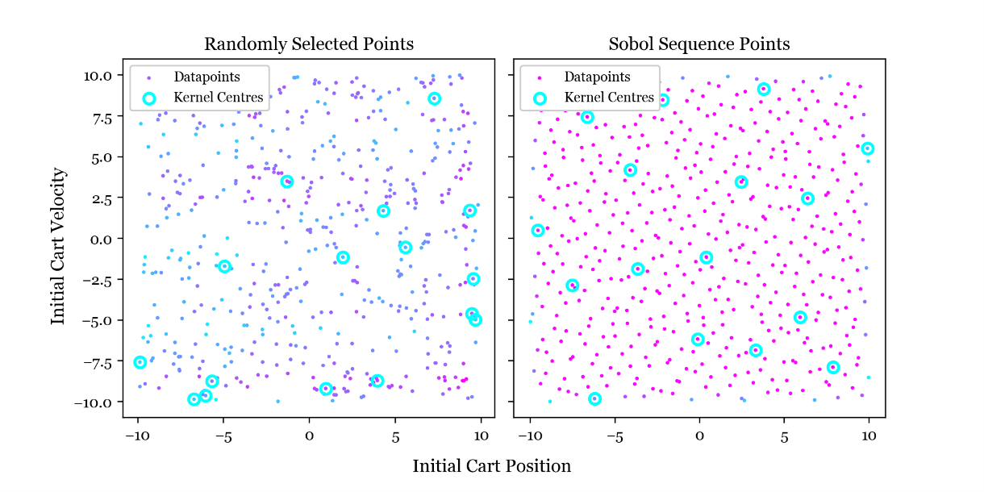**Sobol Sequence.** These are scatter plots of the datapoints generated by the two methods, projected onto the plane formed by the first two state vector dimensions. The dots represent datapoints, and the circled points represent basis function centres. The randomly selected points can be bunched up in some areas, and absent from others. The Sobol sequence provides much better coverage of the state space, meaning more useful information makes it into the model.

**Selection of Kernel Centres.** The Sobol sequence method has another advantage: the first few generated points are also evenly spaced over the state space so they work well as kernel centres (if two kernel centres were next to each other, they would explain the same part of the data so one would be enough). This works best when the number of kernel centres is a power of two; above I have selected the first 16 points as basis function centres. The left plot shows the result of random basis function centre generation, where some kernel centres are very close to each other and there is a large gap in the top left which would lead to poor modelling in that region.

**Evaluation of Fitted Model.** Below are the contour plots of the nonlinear predictions for the state changes, across varying initial pole angle and angular velocity. The nonlinear structure has been captured by the model quite well but it did take a large amount of data and many kernel functions to achieve this. The hyperparameters sigma and lambda were identified by trial and error. Improvements 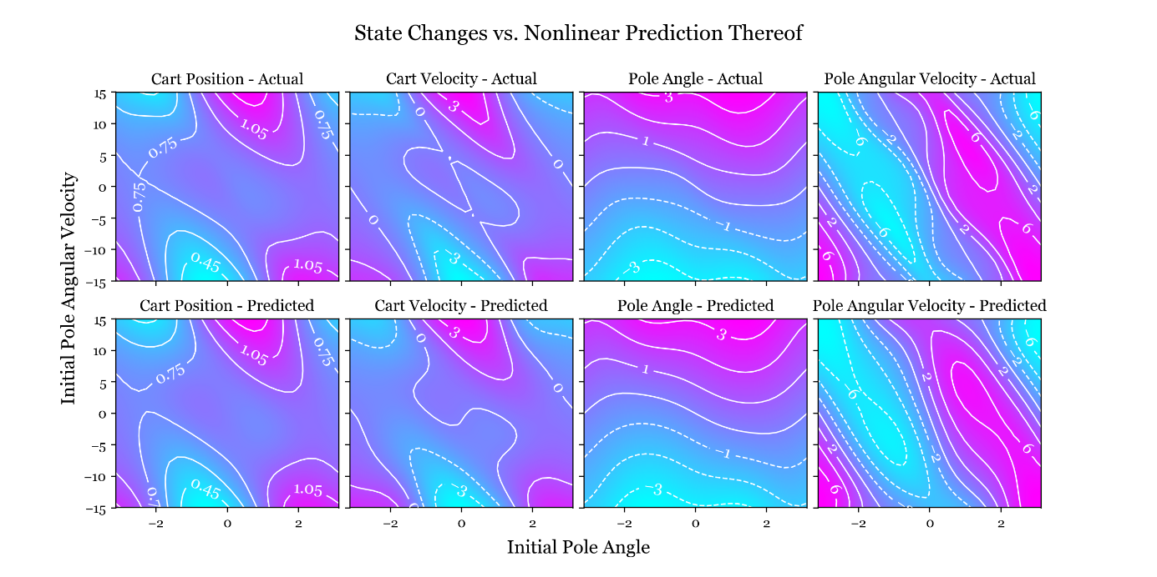to the process might include collecting data further outside the region we would like to make predictions in, pushing errors further away from where we are using the model for prediction. Another improvement could be to collect more datapoints in regions with larger errors, or assign different "weights" to different data points, making them more 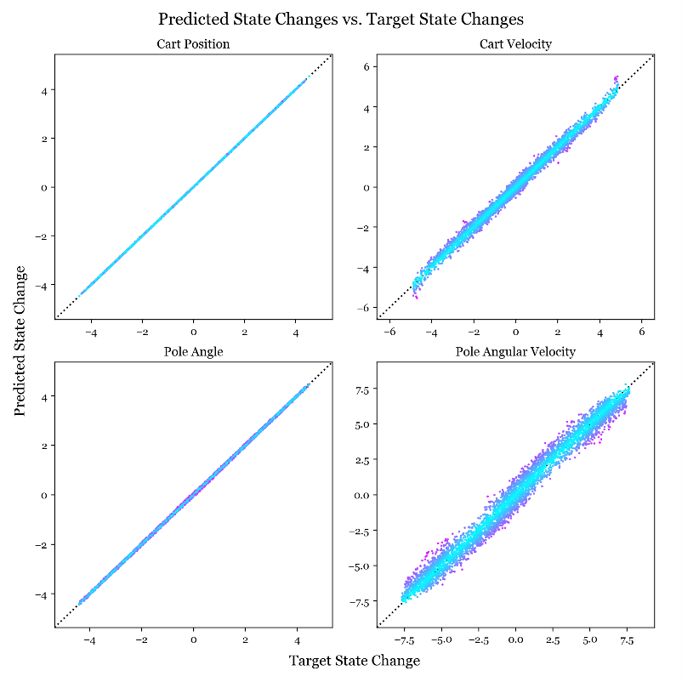or less important for the model to explain well.

To the right I have plotted the target state change against the predictions from the nonlinear model. The points are all lying much closer to the ideal line y=x, so we can expect this model to perform much better than the linear model from task 1.3.

**Effect of Increasing Basis Function Density.** Below I have plotted the prediction for change in pole angular velocity against the actual change for increasing numbers of basis functions. As the number of basis functions increases the fit converges, but plateaus before achieving a perfect fit. Increasing the number of datapoints fed into the model has a similar effect, but fitting the model with more datapoints provides a modelling improvement that only increases computation time during fitting whereas increasing the number of kernel centres increases computation time during fitting and model evaluation.

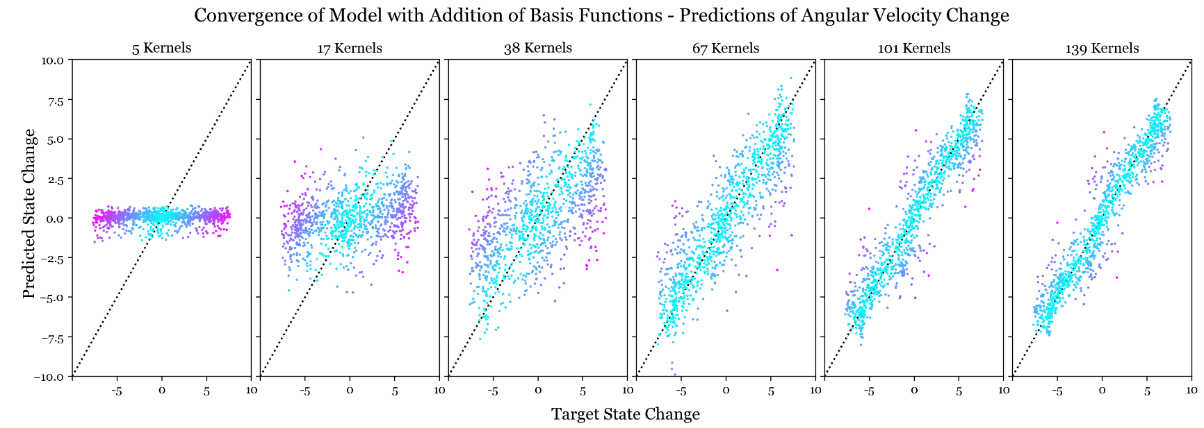

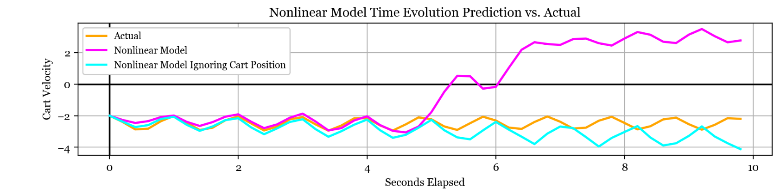

**Nonlinear Model Time Evolution.** Above, I have plotted the time evolution of the system as predicted by the nonlinear model in magenta, and according to the analytic equations in orange. I have plotted the evolution of the cart velocity only because I found while experimenting that if the time evolution of one of the states matches then they all will, and divergence of one state indicates total divergence. Therefore all the meaning I was interested in was contained in the time evolution of a single element of the state vector, and allows me to save space for the final report etc.

There is reasonable agreement up to 5 seconds, and disagreement beyond. The slight mispredictions up to 5 seconds are due to accumulating errors in the model, but the deviation at 5 seconds is indicative of a weakness in the model. At this point, the cart has been moving left at about 2 metres per second for 5 seconds, so has moved 10 metres. The training data and basis function centres were all generated with cart positions within -10 to 10 in state space, so after 5 seconds the cart has moved away from all the kernel centres into a region of the state space that is necessarily badly described by the model.

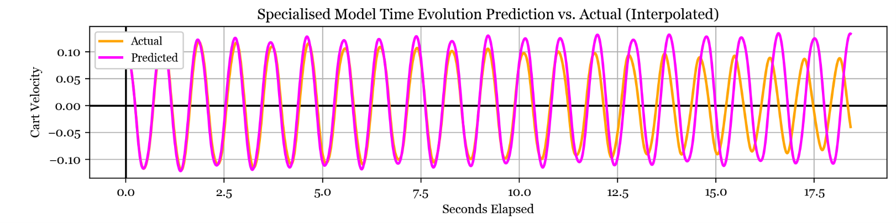**Model Ignoring Cart Position.** So, I adjusted the kernel function to ignore the cart position dimension (which has no effect on the change in state anyway) and refitted the model. The resulting prediction is shown in cyan and is not an exact match to the real dynamics in orange but exhibits more similar overall behaviour. It is also worth noting that when in use, the controller will keep the cart position close to the origin so this adjustment may be inconsequential in that case.

**Descoping the Model.** In order to improve the model's predictions, I restricted the training data to the range relevant to small amplitude oscillations and then examined the time evolution of the predictions exclusively within that same regime. The plot above shows the actual dynamics in orange, and the model predictions in magenta. The predictions are very good up to about 10 seconds, so training the model on only a subset of the data improves predictions in that neighbourhood significantly. Beyond about 7 seconds the real oscillations start to decay - the model struggles to capture this behaviour as it occurs over a larger timescale, while the model can predict only one timestep forward.

**Nonlinear Model Evaluation.** Above I found that the model is able to give agreement for many oscillations with a bit of tweaking, although errors always accumulate. This is to be expected: we trained the model with inputs and targets that were only 1 step apart, so intuitively the model can predict a single time step well but has no understanding that repeated evaluation amplifies undesirable errors. Although we see good predictions from the pointwise accuracy tests, the time evolution exacerbates these errors.

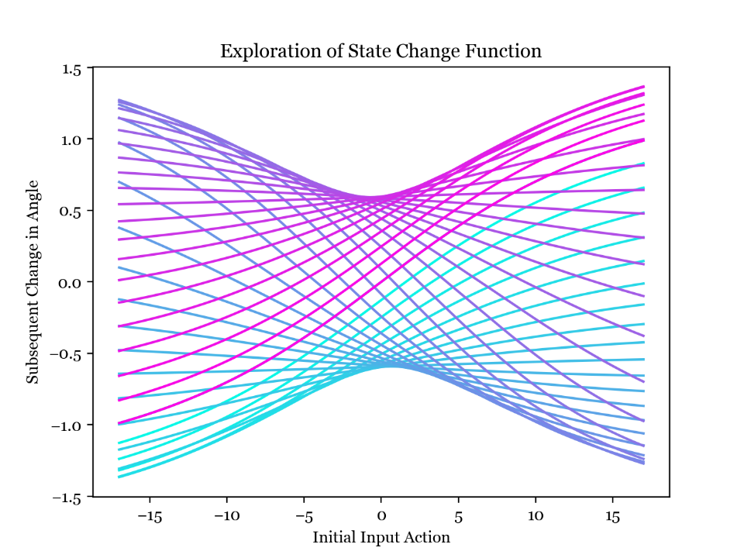**Task 2.2 –** Modelling Effect of Force Input

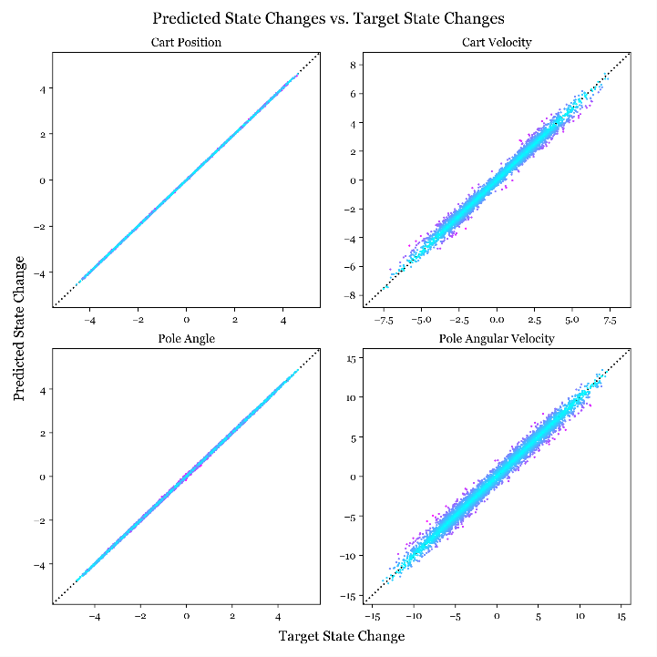**Effect of Input Force.** The system now includes an input force, meaning the state space is one dimension larger. The input force affects the cartpole dynamics within the perform_action function, so by controlling this input it will be possible to hold the pendulum at its unstable equilibrium. In order to visualise the state change function with the force input, I plotted this graph which shows how the initial angle and input action affect the subsequent change in angle. The different lines are different initial angles, from -pi in magenta to pi in cyan, and the input force is varying along the lines.

**Target State Changes vs Predictions, Including Force.** I was able to use essentially the same code as for task 2.1 for fitting the model including the force input, so the results are very similar; for example in these scatter plots comparing target to predicted state change the points again all lie close to the ideal line.

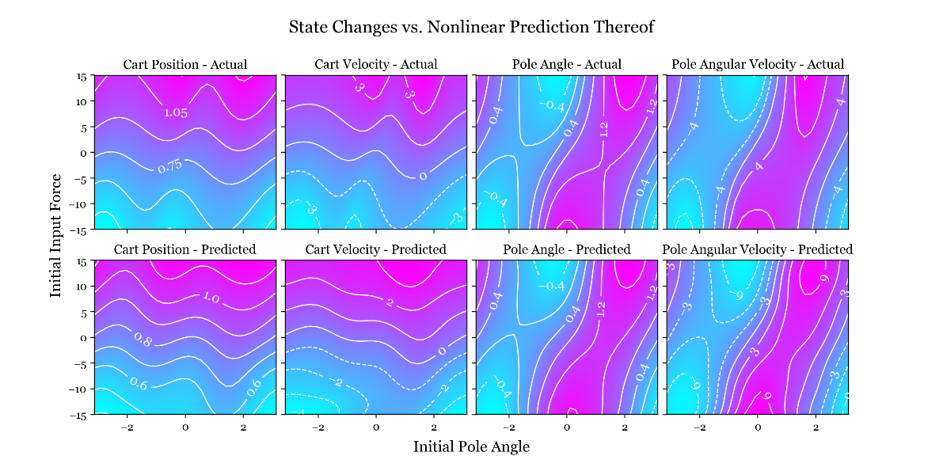Below I have plotted contours of the target state changes as well as the predictions from the nonlinear model. I have varied the initial pole angle along the x axis and initial input force along the y axis, and there is good agreement between the two sets of contours. However, discrepancies are easier to find in these plots than in those without the force input.

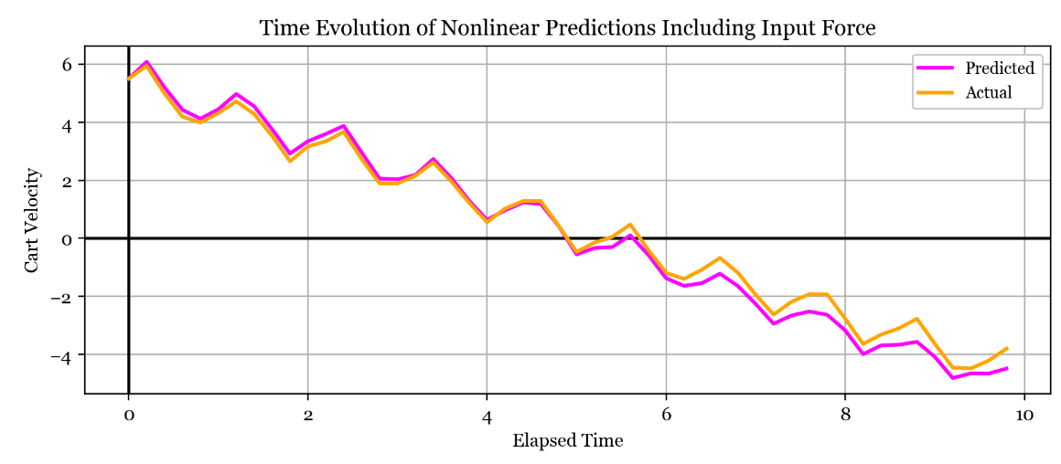**Time Evolution Modelling.** Below is the time evolution of the cart velocity with predictions in magenta and analytic in orange; the close agreement shows that the model has understood this motion well. Although this initial condition leads to good agreement, others lead to divergence more quickly. We might expect the predictions when including the force input to be worse since the state space has become much larger; I have set the input force to be between -15 and 15 in training data so the additional travel in this dimension effectively reduces the data density and basis function density in the state space. In other words, the model has to fit a larger and more complex state change function with sparser information about it and using the same number of kernels. Using more basis functions and datapoints to compensate for this effect makes the fitting process take much longer.

**Task 2.3 –** Linear Control

Now I am interested in controlling the cartpole system using a linear policy $p(X)=p∙X$ to set the action at each timestep. The vector $p$ is determined by minimising a loss function $L$, defined by summing a point loss function evaluated at each time step over a certain timeframe:

$$L=\sum_{i=1}^{N}{l\left(X_{i}\right)}$$

$$l\left(X\right)=1-exp\left(-\frac{{\left|X\right|}^{2}}{2σ_{l}^{2}}\right)$$

First, note that finding L involves repeated evaluation of the cartpole dynamics as defined in perform_action. To speed up the fitting process, I reimplemented the Euler integrator using the RK4 method which improves accuracy and executes in roughly half the time – for details see perform_action_RK4(state) in CartPole.py.

Also note that the provided loss function can ascribe a large loss to a cartpole in the desired configuration if the pole angle is not zero but actually a multiple of $2π$. Therefore an improved loss function could be periodic in the pole angle variable, similar to the correction used in the kernel functions in task 2.1. The same is true for the linear policy: $p∙X$ could be nonzero in the desired configuration if the pole angle is a multiple of $2π$.

Next, I implemented the loss function L and created some contour plots to visualise how it varied across the policy space. I then used scipy.optimize.minimize with the Nelder-Mead method to find an optimal setting of the policy vector p. I made several calls to the minimize function, each starting from a different initial value of the p vector, and took the one that gave the smallest loss. I also implemented an optimisation where the loss function L would return the maximum value if any of the elements of the state vector grew too large. This helped to reduce the number of perform_action calls that needed to be made as poor policies were identified earlier in the process.

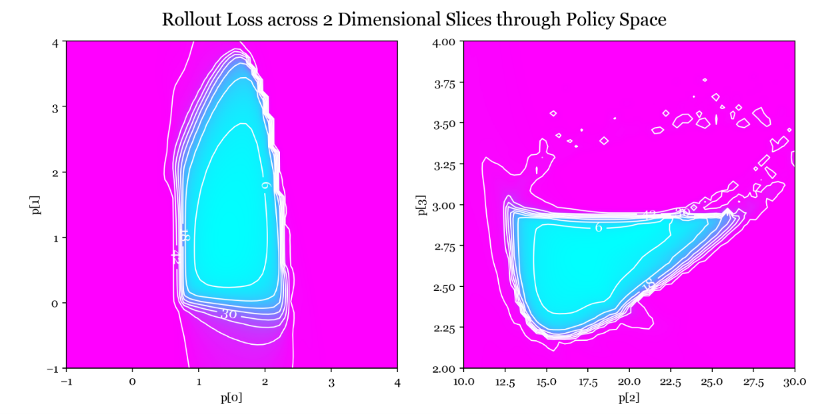**Loss Contour Plots.** Above I have plotted the total loss evaluated at values of the p vector across two orthogonal slices through one of the minimums. The optimal value of the p vector found by the optimiser is the intersection of these two planes. I was lucky to find this minimum and will probably not find any more since the policy space is so large and the portion where the loss isn't maximal is a tiny fraction of it - magenta shows maximal loss and cyan anything below.

One thing about this loss function is that there are large areas with very small gradients, which would make classical machine learning techniques like gradient descent difficult to apply. One possibility is to try the log of the loss function which might help regularise the gradients, or adjust the loss function so that it doesn't reach a maximum as the current one does. I used the Nelder-Mead method so that the gradients weren't a factor, but noted that a lot of bad policies were found with this method. Using many different starting locations allowed me to find decent policies but if this hadn't worked I would next try to adjust the definition of the loss function to help the optimiser work better.

**Stabilised Range of Initial Conditions.** The optimised policy vector that my search returned is p = [ 0.76, 1.44, 17.06, 2.66 ]. This setting of p is able to stabilise the cartpole from initial angular displacements around 0.6 and initial cart displacements around 2 metres. These ranges can also be increased by favourable initial linear and angular velocities. Increasing the initial cart displacement beyond this resulted in a large initial force that caused the system to lose control, as the contribution from the cart position became too large. However, we can leverage the translational invariance of the system to avoid this: by clipping the first element of the state vector between -2 and 2 just before it is fed into the policy function $p(X)$, the policy thinks it is only at most 2 metres from the equilibrium. So it still moves the cart towards the desired state at the origin, but without overdoing it. However, this is no longer a truly linear model.

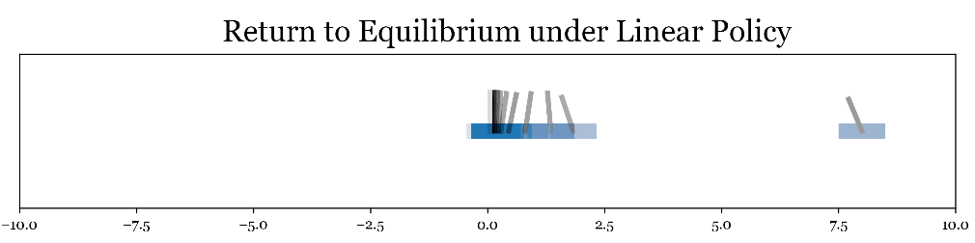I created a little graphic showing how my optimised policy brings the cartpole to the desired state, starting from the extreme left.

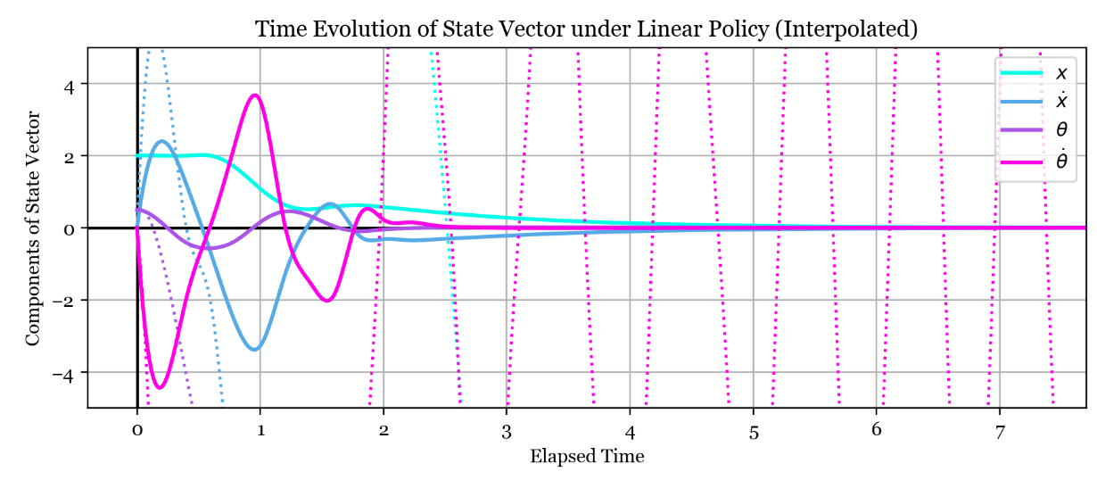**State Vector Evolution with Time.** In the plot below each solid line is one component of the state vector as they vary under the linear policy, starting from an intial state X = [ 40, 0, 0.5, 0 ]. All the components are brought to zero as desired and you can also see the horizontal part of the cyan line (representing the cart position) where the position clipping is coming into effect. The dotted lines show the states without the position clipping, and are highly unstable.

**Task 2.4 –** Model Predictive Control

I tried to use the same optimised policy vector p to control the modelled dynamics, and found that the same policy vector was able to bring the modelled system to the desired state but took slightly longer to do so.

**Model-Based Optimisation.** I changed the rollout loss evaluation function to use the modelled dynamics, and then re-ran the optimisation process to find a new policy vector noting that the process was much faster because the model is cheaper to evaluate than the actual dynamics (this provides motivation for performing model predictive control). Thinking that the model dynamics aren't too different to the real ones, I used the previous optimal policy vector as the starting point for the optimisation and found the following optimal policy vector: p = [ 2.42, 3.82, 22.41, 3.96 ].

Below I have plotted the time evolution of the state vector under the model-optimised linear policy, and using the modelled dynamics. Although the cart and pole positions are relatively stable at the desired configuration, there are oscillations in the linear and angular velocities about the equilibrium, although these stop growing after 8 seconds. These oscillations are of period 0.4s so are formed by overshoot and correction during 2 subsequent calls to perform_action; I think these are acceptable as they don't cause the cartpole to really deviate from the desired configuration.

However, if I wanted to avoid this oscillation the loss function could be adjusted to discourage it. For example, the total rollout loss function could ignore the first few seconds and only include states afterwards. This could select for policies that take a bit longer to get the pole upright and stable, but are 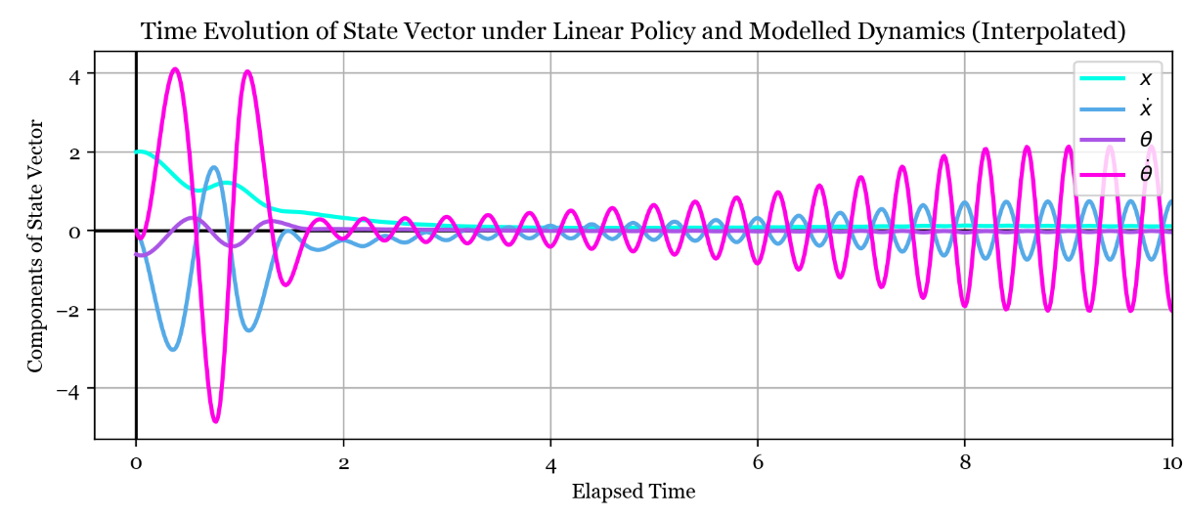subsequently able to hold it completely still. Other adjustments to the loss function could include penalising force input also, to encourage efficient control.

In general, the model predictive control method has not performed as well, with these oscillations proving very hard to avoid. The other big problem with the model-optimised policy is that it's much more sensitive to initial conditions: carefully selected small initial displacements can lead to divergence. So it seems that using the model for dynamics has caused the policy to miss some of the generality that the previous policy was able to capture, maybe due to the model being ignorant of certain features of the true data.

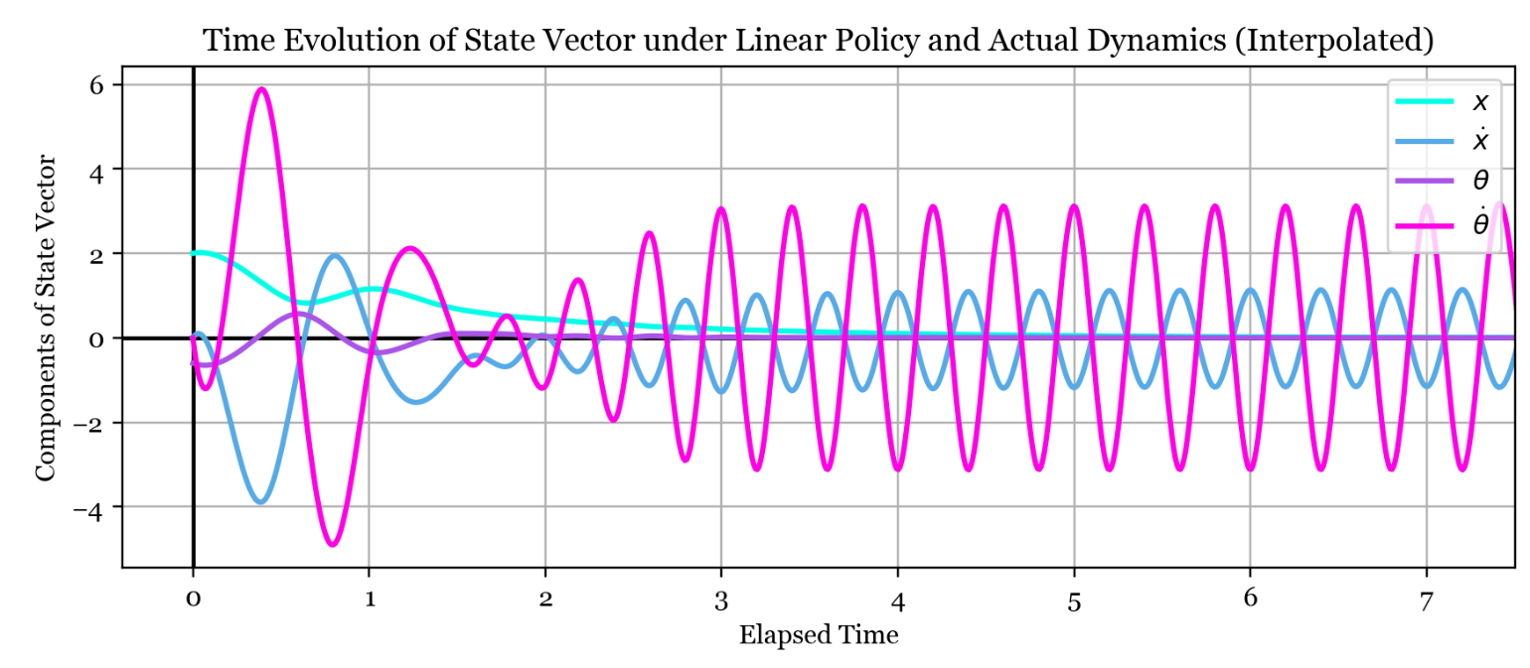**Return to Actual Dynamics.** I then tried to use the policy vector optimised on the model to control the actual dynamics. The oscillations in linear and angular velocity have become larger. However, the pole and cart positions are successfully controlled to the desired state. Again, the policy is more sensitive to initial conditions. I would say that the model predictive control approach has worked reasonably well but definitely has suffered a loss in stability and generality.